DSC 640 – Project Milestone One – Airline Safety Dashboard

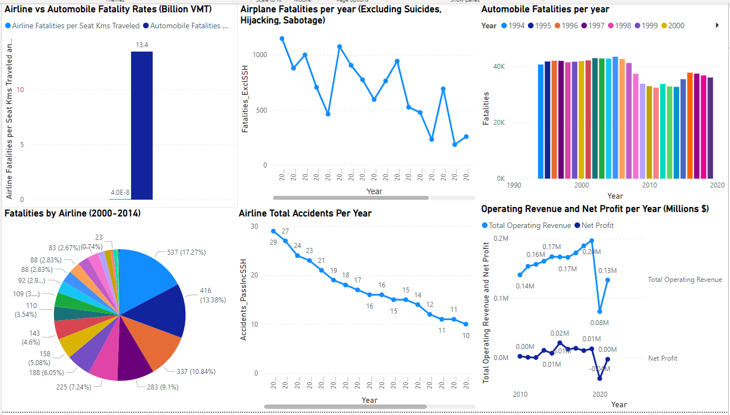

**Summary:**

As a data analyst at an airline company, I have been tasked with investigating media claims that air travel is no longer a safe way to travel. To help internal stakeholders combat this I created a high-level dashboard containing key information related to Airline safety and the negative publicity’s effect on our company. To begin with the dashboard contains a comparison of fatality rate for Airline and Automobiles based on Billion vehicle miles traveled. The next visualizations show the declining trend in airline fatalities by year in a line chart and the total number of automobile fatalities per year in a bar chart. I have also included a pie chart indicating the number of fatalities by airline company for the years 2000-2014. Next, I have included a line plot showing the declining trend in total airline accidents and the trend in Operating Revenue/Net Profit by year.

**Presentation Plan:**

To begin my presentation, I would provide context on the media narrative around air travel before discussing where our company falls in the industry for number of fatalities. Understanding this may help our team determine if we want to shift focus to a single competitor if they are responsible for many fatalities with our own stats being low this could be an opportunity to use that to poach customers. Going forward we can examine the declining trends in fatalities and total accidents per year for airlines. This can be a launching point for discussion comparing the airline industry fatality rate and total fatalities per year to the automobile industry for talking points for the marketing team to use against the media narrative. Lastly, we can review the operating revenue and net profit per year to examine if we believe the media narrative has been impacting our bottom line.

**Ethical Considerations**

As with any project, we must ensure that our data is validated to ensure there are no misrepresentations or bias especially as this data is related to the safety of our airline and potentially life/death decisions for consumers.

Reference:

[Fatality Analysis Reporting System (FARS) | NHTSA](https://www.nhtsa.gov/research-data/fatality-analysis-reporting-system-fars)

[Impact | Airlines For America](https://www.airlines.org/impact/)

[Accidents and fatalities per year - Google Sheets](https://docs.google.com/spreadsheets/d/1SDp7p1y6m7N5xD5_fpOkYOrJvd68V7iy6etXy2cetb8/edit#gid=1448957446)

[data/airline-safety at master · fivethirtyeight/data (github.com)](https://github.com/fivethirtyeight/data/tree/master/airline-safety)